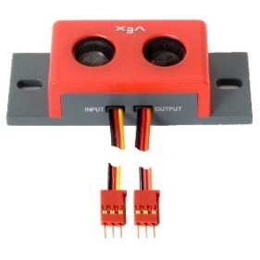
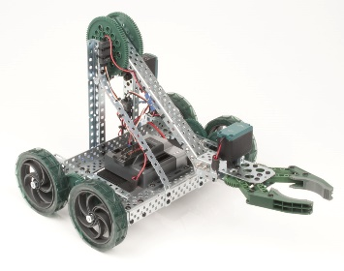
COLLISION
AVOIDANCE
Technology & Engineering
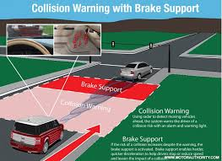
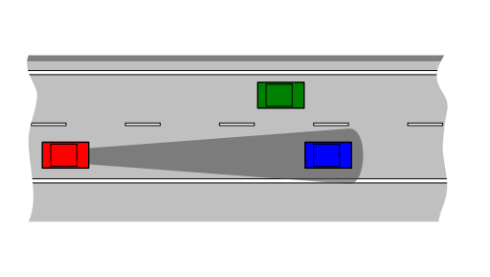
Mr. Roth
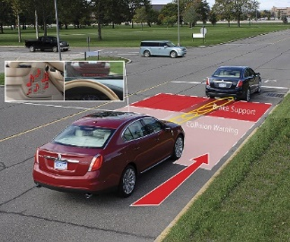

Collision avoidance is the maintenance of systems and practices designed to prevent vehicles such as cars, trains, ships, and airplanes from colliding with other vehicles. TCAS/ACAS systems have been required on commercial aircraft since 1986, and similar systems are just now coming to standard models of modern automobiles.

In cars, collision avoidance systems are an integrated safety system designed to reduce the severity of or completely avoid an accident. Also known as a precrash system, forward collision warning system or collision mitigating system, it uses radar (all-weather), and sometimes laser and camera (good weather only) to detect an imminent crash.

When the vehicle senses a potential obstacle or imminent collision, these systems either provide a warning to the driver or take action autonomously without any driver input (by braking or steering or both). Collision avoidance by braking is appropriate at low vehicle speeds (e.g. below 50 km/h), while collision avoidance by steering is appropriate at higher vehicle speeds.^{[1]} Cars with collision avoidance may also be equipped with adaptive cruise control, and use the same forward-looking sensors.

Objective: Re-engineer portions of your ClawBot / Police Robot to adhere to the rules of the challenge:
- Your robot must be capable of moving forward at top speed, driving along a straight course from a starting point and traveling as fast as possible toward a brick wall or another vehicle/obstacle.
- It must be operated by a driver using remote control.
- Be operated continuously by the driver at FULL SPEED. The DRIVER MAY NOT MANUALLY SLOW THE VEHICLE AT ANY POINT DURING THE TEST.
- Using sensors, and programming, the vehicle must:
- Continuously detect an obstacle and provide visual cues, while still a safe distance from it (48-115 in.).
- Continuously detect the obstacle, provide a different visual cue to the driver, and perform autonomous, assisted braking to slow the vehicle to ½ speed while still a safe stopping distance from it (12-48 inches).
- Continuously detect the obstacle, providing a third, different visual (AND possibly a fourth, non-visual) cue to the driver to wake him or her from his probable slumber, and autonomously COMPLETELY STOP the vehicle while still a safe distance from it (0.125-12 inches). Any collision will result in significant point deductions.
- In the event of collision, a passive restraint system (e.g. airbags, seat belt pre-tensioners, etc.) must activate. Activation of the system will be simulated using visual cues.
- Return to driver/remote control, be able to reverse course and return to the start.
BONUS POINTS will be awarded to groups that subsequently program the vehicle to autonomously avoid the obstacle.
Name ________________________________________ Name ________________________________________
Name ________________________________________ Name ________________________________________
Name ________________________________________ Class Period _______________________
COLLISION
AVOIDANCE
Technology & Engineering
Mr. Roth
 | 4 | 3 |  | 2 | 1 | 0 | Score
Existing ClawBot and Police Vehicle Systems (all existing systems/subsystems except any modified by nature of this project)
Robot | All required components are still present, assembled, and functioning | All required components are present and function efficiently |  | Most required components are present and/or partially function | Some required components are present but do not function | Few required components are present and do not function
Required Modifications to ClawBot Subsystems
Chassis | Chassis modified to allow robot to remain stable / upright at all times. | Allows robot to remain upright; poss. Stability issues. |  | Allows robot to remain upright; some stability / balance issues. | Not modified to keep robot upright and stable. | Chassis not present.
Drivetrain | Drivetrain modified to allow robot to handle all types of terrain and remain stable. | Allows robot to handle all terrain, possible stability issues. |  | Allows robot to handle most terrain; stability issues. | Allows robot to handle only flat, paved terrain. | Drivetrain not present.
Claw Structure & Actuator | Claw & Actuator are removed and do not interfere w/operation. | -- |  | Claw/Actuator are not removed but do not interfere. | -- | Claw/Actuator are not removed and do interfere.
Required Modifications for this Challenge
Collision Avoidance | Ultrasonic rangefinder is installed and actively/accurately finds obstacles. | -- |  | Ultrasonic rangefinder is installed but is not reliable. | -- | Ultrasonic rangefinder is not installed or active.
Passive Restraint System | Push button switch is present and activates the passive restraints in event of collision. | -- |  | Push button switch is present but does not reliably activate the passive restraints. | -- | Push button switch is not present or functional.
Visual alerts / cues | Vehicle shows diff. visual alerts when obstacles are detected inside the safe zone, warning zone, and braking zone. | Vehicle capable of showing two different visual alerts – inside warning zone and braking zone. |  | Vehicle shows same visual alert when obstacles are detected inside the three zones. | Vehicle has a visual alert system, but it does not function. | Vehicle is not capable of producing visual alerts.
Programming
Program | All required code / routines are present, with correct syntax, robot fully functions | Most required code / routines are present, syntax mostly correct, robot functions | Some required code / routines are present, many syntax errors, partly functions |  | Few required code / routines are present, many syntax errors, partly functions | Few required code / routines are present, many syntax errors, robot does not function
Push Button | All required code is present, correct syntax, routine fully functions | Most required code is present, syntax mostly correct, robot functions | Some required code is present, many syntax errors, partly functions |  | Little required code is present, many syntax errors, partly functions | No required code is present, many syntax errors, robot does not function
Remote Control | All required code is present, correct syntax, routine fully functions | Most required code is present, syntax mostly correct, robot functions | Some required code is present, many syntax errors, partly functions |  | Little required code is present, many syntax errors, partly functions | No required code is present, many syntax errors, robot does not function
Ultrasonic Rangefinder | All required code is present, correct syntax, routine fully functions | Most req’d code is present, syntax mostly correct, robot functions | Some required code is present, many syntax errors, partly functions |  | Little required code is present, many syntax errors, partly functions | No required code is present, many syntax errors, robot does not function
Overall System Test / Performance
Function and connection of subsystems | Individual subsystem components are properly connected, work together, and system functions properly when tested | Components are improperly connected, causing sub-system to malfunction. |  | Components are improperly connected, causing sub-system failure. | Components are improperly connected, causing sub-system failure and partial system failure. | Components are improperly connected, causing massive or total system failure or inoperability.
Robot / Challenge Performance
Remote Controlled | Fully operated by remote control | -- |  | Partly operates by remote control. | -- | Does not operate by remote control
Maneuvers | Drives straight and at full speed until… | -- |  | Drives straight but not at full speed. | -- | Does not drive straight or at full speed
Maneuvers | Ultrasonic rangefinder sees object at 115 in. | -- |  | Sees objects at 81.5” or less. | -- | Rangefinder cannot see objects until 48”.
Maneuvers | Visual Cue #1 from 115 in. to 48 in. | -- |  | Visual Cue #1 from 81.5 in. to 48 in. | -- | Visual cue #1 fails from 115” to 48”
Maneuvers | Ultrasonic rangefinder sees object at 48” | -- |  | Sees objects at 30” or less. | -- | Rangefinder cannot see objects until 12”.
Maneuvers | Visual Cue #2 and Half Speed at 48” to 12” | -- |  | Visual Cue #1 from 30 in. to 12 in. | -- | Visual cue #1 fails from 48” to 12”
Maneuvers | Ultrasonic rangefinder sees object at 12” | -- |  | Rangefinder cannot see objects until < 3” | -- | Rangefinder cannot see objects.
Maneuvers | Visual Cue #3 and Zero Speed at 12” to 0.125” | -- |  | Visual cue #1 fails from 3” to 0.125” | -- | Visual cue #1 fails from 12” to 0.125”
Maneuvers | Vehicle stops before crash. | -- |  | At half speed, does not stop; crashes | -- | Vehicle at full speed does not stop; crashes
Maneuvers | Vehicle returns to driver control | -- |  | Vehicle was always under driver control. | -- | Does not return to driver control.
Maneuvers | If crash occurs, push button activates SRS and disables vehicle | -- |  | Push button temporarily activates SRS; not disabled. | -- | Push button / SRS fails; occupants likely injured or worse…
Total System / Team Scores
Time and Resources | Resources properly used. Time maximized. | Resources utilized with min. waste. |  | Moderate waste. Lack of efficiency. | Poor use of resources or time. | Poor use of resources AND time.
Team Score | Consistently functioned as a team. Always focused. | Consistently functioned well. Mostly focused. |  | Occasionally functioned well. Occasionally focused. | Seldom functioned as a team. Seldom focused. | Never functioned as a team. Never focused.
Average Individual Score From Team Evaluation |  |  |  |  |  |  | /10
Total Score
Total Possible |  |  |  |  |  |  | 110

Comments:

